**Question 1 :- Write code to extract the actual content of the current version of a Wikipedia page in the missing code.**

**import** **requests**

title='parsing'

response = requests.get("http://en.wikipedia.org/w/api.php?format=json&action=query&titles="+str(title)+"&prop=revisions&rvprop=content")

jsondata = response.json()

**content = jsondata['query']['pages'].values()[0]['revisions'][-1]**

**The above line gets the current version.**

Question 2 :-  Load the first sentence of the “parsing” wikipedia article using the stanford parser GUI. Did it parse correctly? Explain.

**Yes, the first statement of the “parsing” page from wikipedia parsed successfully. Please find the attached screenshot of the gui for the same.**

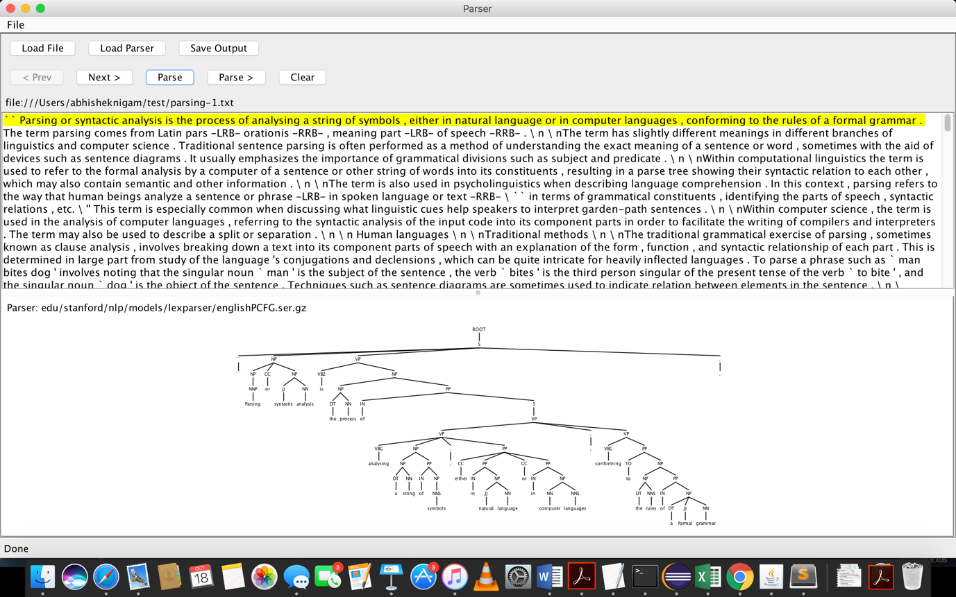

**Question 3 :-** Modify the given testnode function such that other facts about cats can be extracted, use the aganetact2 function below to test it.

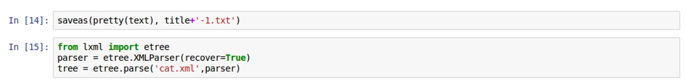

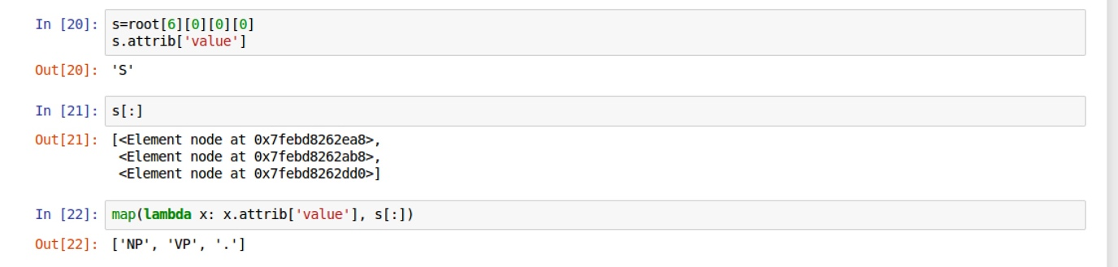

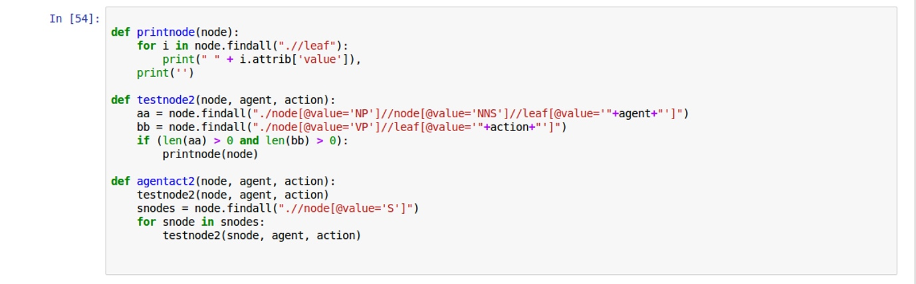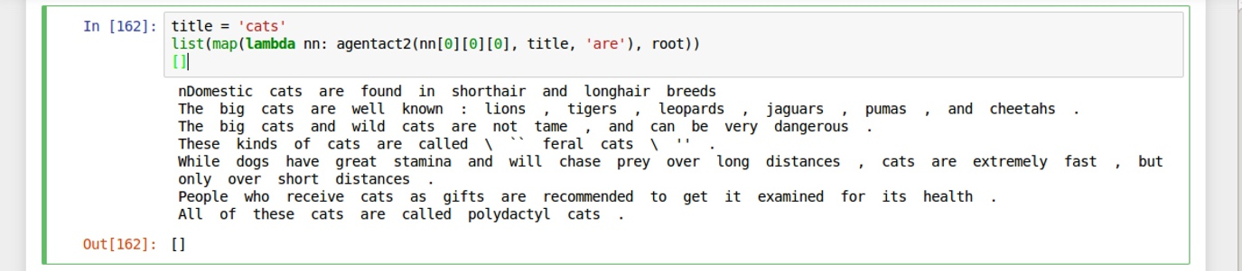

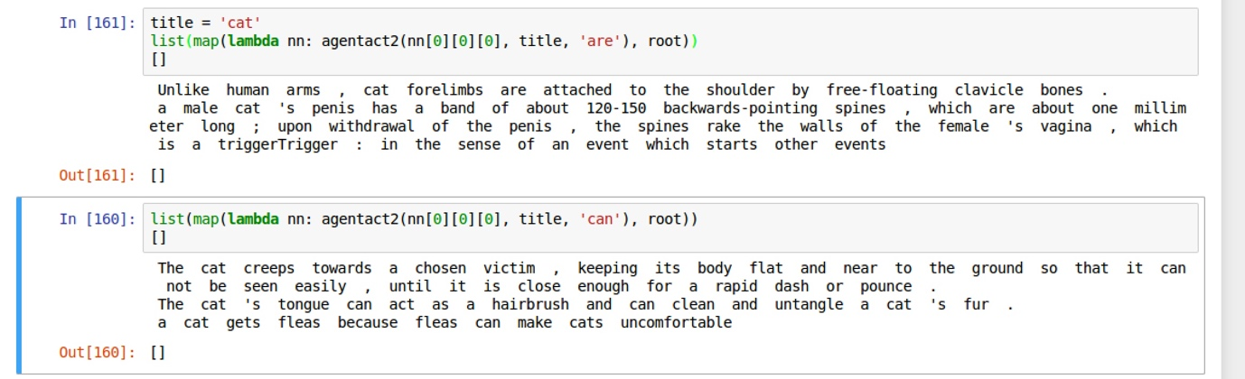

**As shown above, we have modified the testnode2 function finds other relevant facts about the cat using the verbs “are” and “can”. We have later tested this code using the agentact2 code**.

**Question 4 :- Q4. Extract facts about this people’s wikipedia pages  
       -- Jim Parsons  
       -- Barack Obama**

**JIM PARSONS :-**

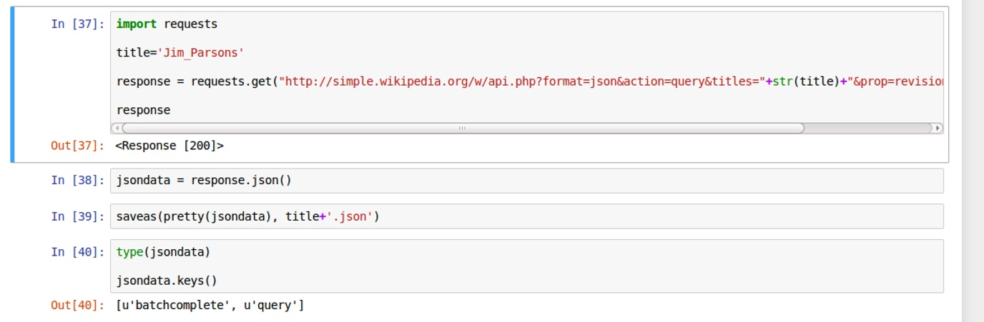

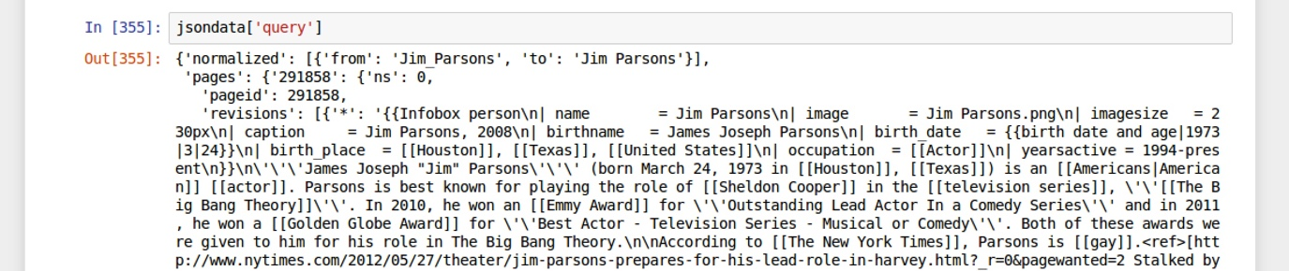

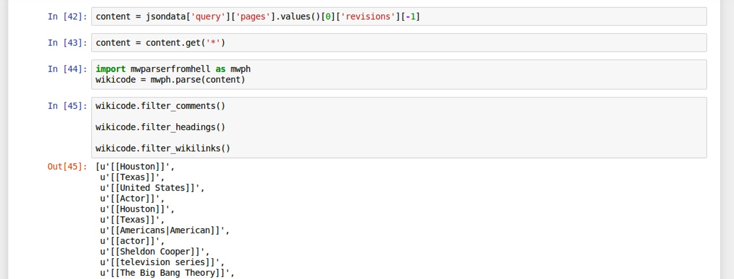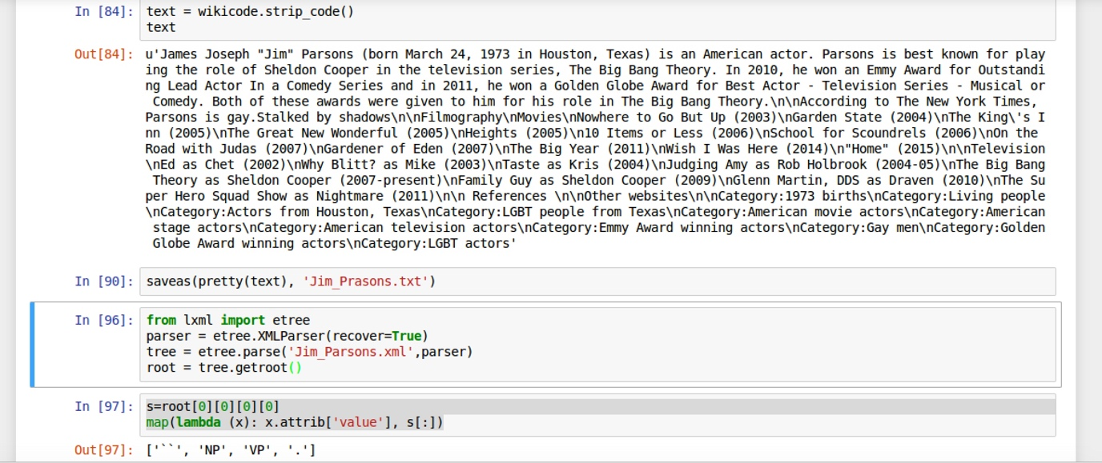

Below be have created a testnode3 function which is specialized to find the facts about a person. In this, we can pass multiple nouns and verbs which are first split and then searched across the XML. We also manually append pronouns like “he”,”she” because the sentences don’t necessarily address a person by his/her name.

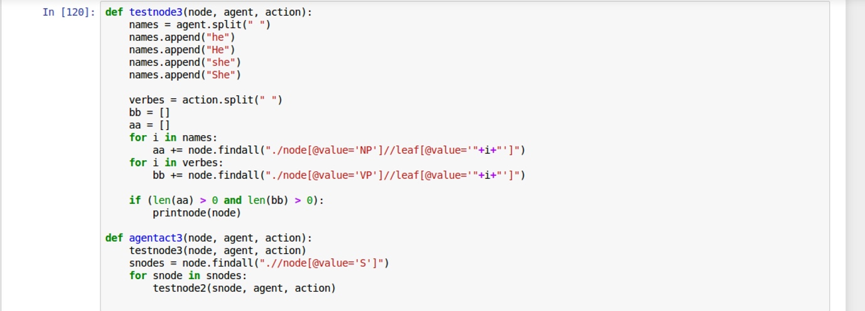

**Below are the facts outputted by the language processing that we have used for Jim Parsons.**

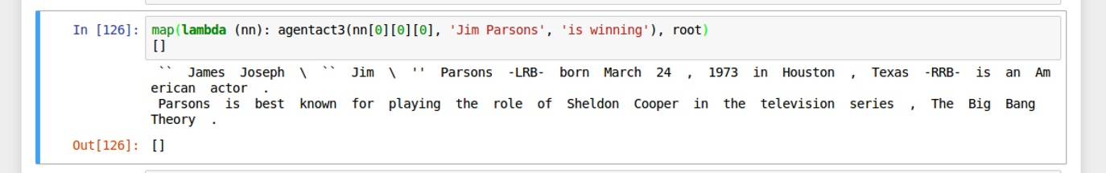

**BARACK OBAMA :-**

Similarly for Barack Obama after creating his XML tree using the lexparser.sh, we pass it to the already created testnode3 function which specializes in finding facts about a person.

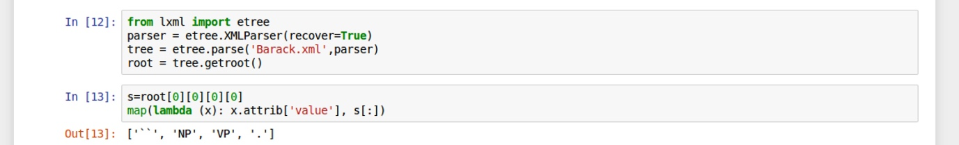

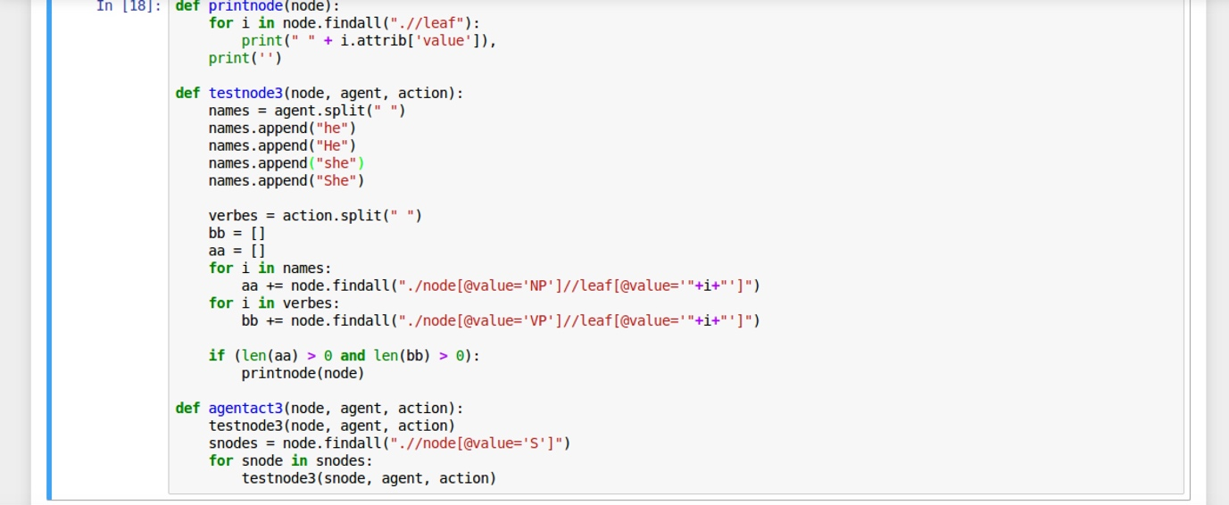

**Below are the facts outputted by the language processing that we have used for Barack Obama.**

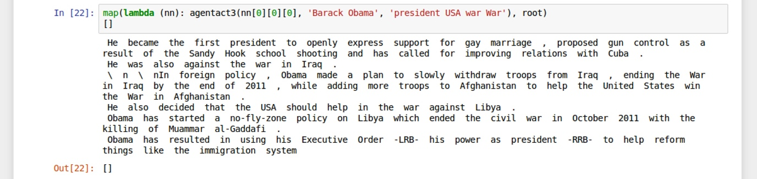

**Question 5 :-**

 Can you write code to automatically extract the following type facts about a given person’s wikipedia page? Test your code using Barack Obama’s wikipedia page  
       -- Place of birth  
       -- Spouse  
       -- Schools attended

**We have written two generic functions testnode2 and testnode3 which finds the appropriate information using the grammar provided. They take in the parameter name and parameters like “born” and “in” for Place of birth and “University”, “College” to find the appropriate sentences for any input.**

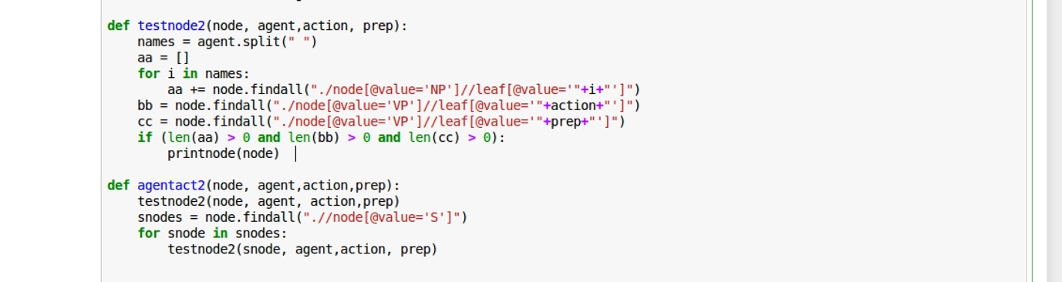

**-- Place of birth :-  
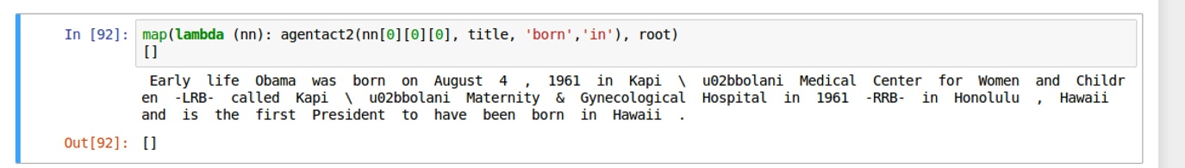**

**-- Schools attended :-**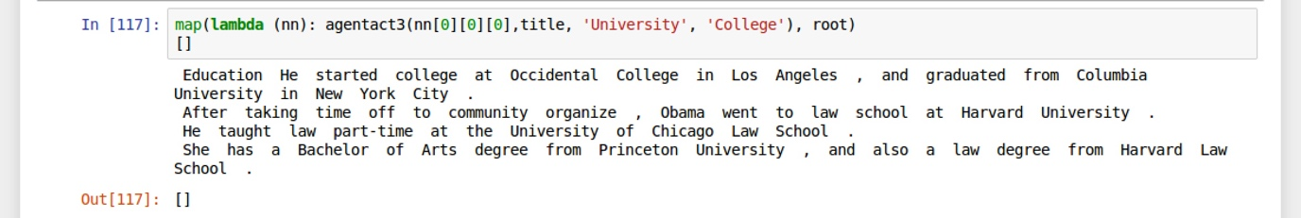

**For Spouse we have written another set of functions i.e testnode3 and agentact3. These are generic functions and when we provide them with POS like “wife” and “married” they return the correct output.**

**-- Spouse :-**

